36.6: a) According to Eq. 36.2
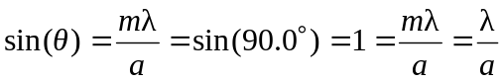
Thus, 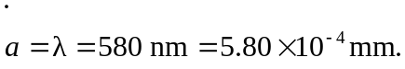

b) According to Eq. 36.7
